Spiroguards Encyclopedia
Spirit-Guardians
Total Number of Spiroguards so far: 4
Every single being in the spiritual hologram has a Spiroguard. When they are not in the physical plane made of slowed down light they can be found in higher dimensions of the spiritual hologram called The Spirit Realms. In the Spirit Realms Spiroguards run free and wild and have many adventures. They appear when they are most needed and come to the aid of the one they have been assigned to guard. To be a guardian of the light is a Spiroguards purpose.
Spiroguards have special magical abilities gifted to them by the creator (O-shimmery-wow) these abilities are unique to every Spiroguard every Spiroguard has a unique one of a kind inner omiga (inner spirit spark) an ori’s (self) needs to tap into their inner omiga to accomplish spell crafting (magic with the power of sound/voice). A Spiroguard is always learning and exploring their own inner omiga’s potential in The Spirit Realms to be better guardians. There potential is limitless.
The first Spiroguard we will introduce is Techimon.

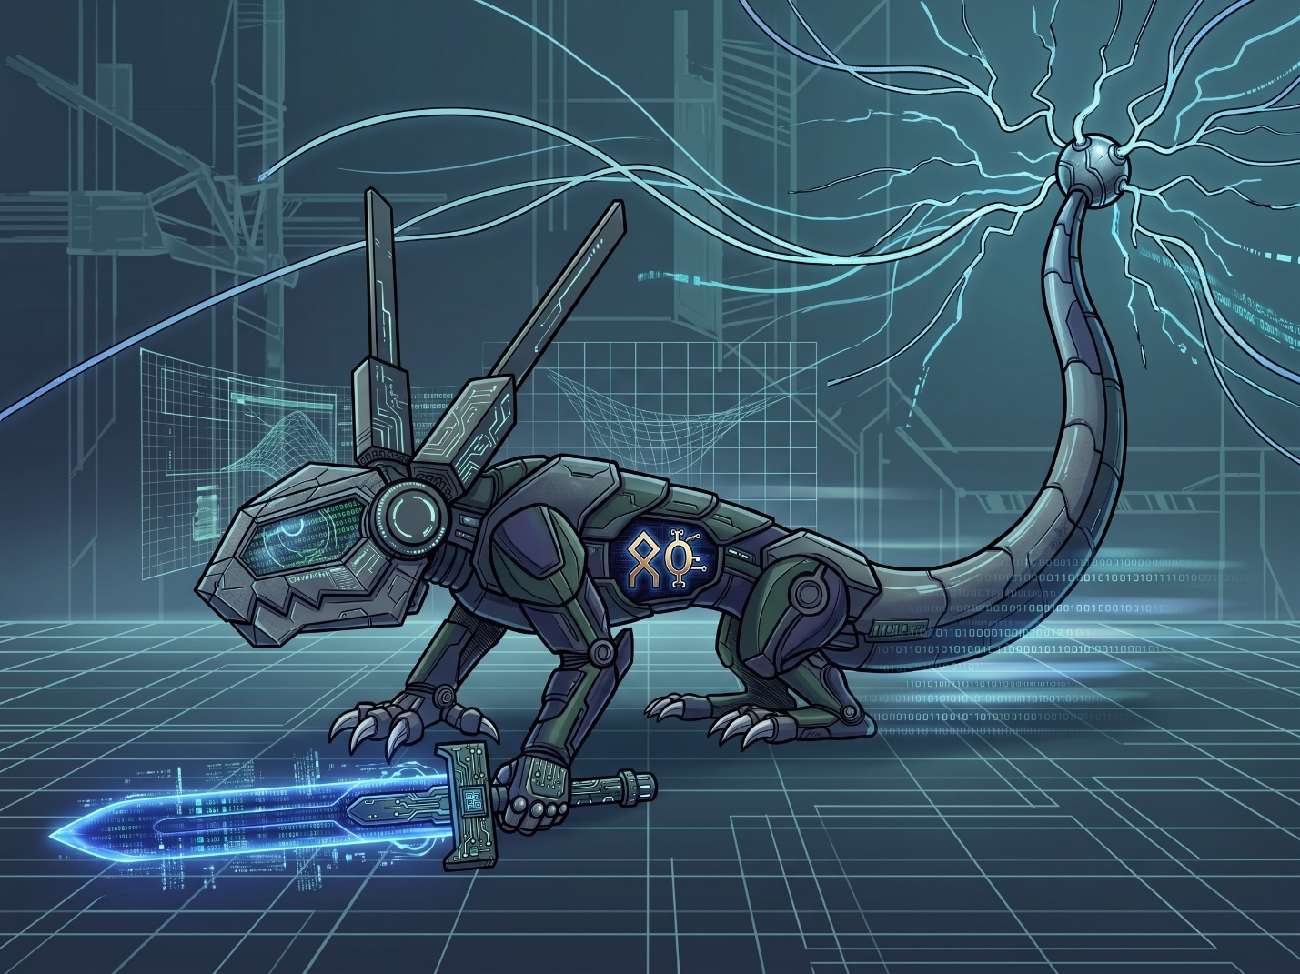
Techimon is a digital Spiroguard. He carries a digital sword. He doesn’t see the way normal beings see. He sees a digital matrix version of the spiritual hologram. He can hack into anything digital just by being close to it. Sometimes with great focus he can hack computer defense systems from a far distance. His tail is a weapon of pure digital electricity. He is also capable of running at super fast speeds up to 1000 km/hr. The runes on his body are the symbols for his name Techimon.
SPIROGUARD ENTRY #[0001] | TECHIMON = Class/Type: Digital / Cyber-Construct Domain: The Matrix Frequencies (Spirit Realm) Element/Affinity: Pure Digital Electricity / Code Manipulation Bonded Ori: [Jax Cutes or Jaromino Cutes]
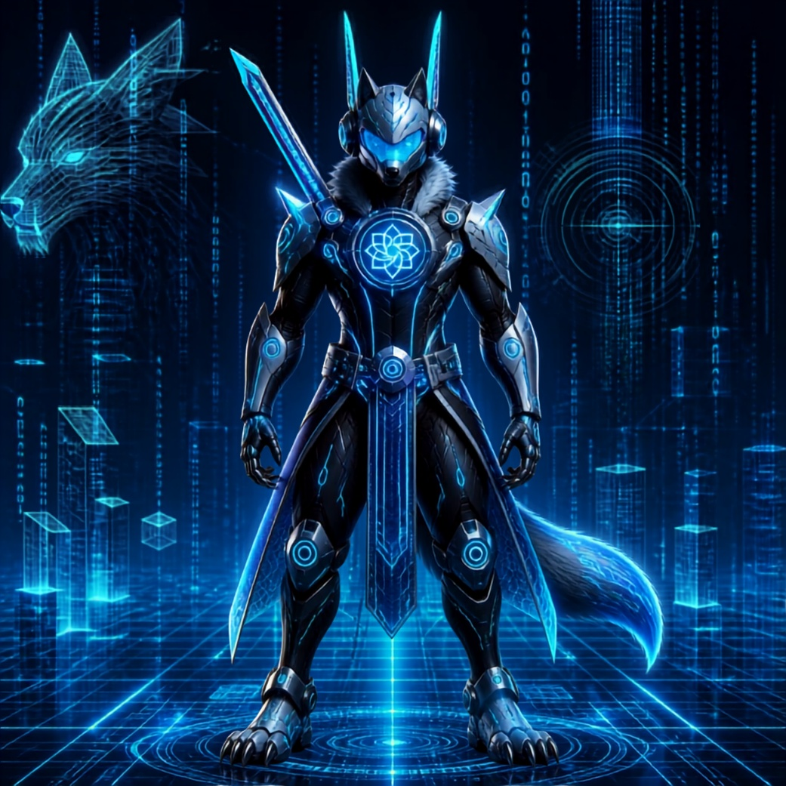
SPIROWOW DOSSIER | GOD-CLASS EVOLUTION DESIGNATION: TECHIWOW (The Omnipresent Cyber-Wolf) BASE FORM: Techimon (Entry #0001) CLASSIFICATION: Divine Cyber-Guardian / Transcendental Spirit Knight DOMAIN: Root Directory of the Spiritual Hologram EVOLUTION DURATION: Brief / Situation-Critical (Emergency Resonance Only)
OVERVIEW & LORE: THE SPIROWOW TRANSCENDENCE
When a Spiroguard’s assigned Ori reaches a moment of ultimate peril or absolute spiritual harmony, the Spiroguard’s inner omiga (spirit spark) can temporarily overflow with the direct divine frequency of O-shimmery-wow.
This event triggers the Spirowow Transformation—a rare "God Status" evolution that turns a standard guardian into a cosmic powerhouse.
Because the raw energy required to maintain a Spirowow form exceeds the safety thresholds of physical and spiritual planes, Techiwow can usually only manifest for brief, high-stakes moments. Maintaining God Status for too long risks burning out the local matrix projection or shattering the physical environment with raw light.
VISUAL & PHYSICAL PROFILE (Based on Visual Asset)
- Humanoid Cyber-Paladin Chassis: Unlike Techimon's standard form, Techiwow stands fully erect in an imposing, bipedal warrior stance, combining sleek metallic armor with rich, high-tech fur trims around the neck and tail.
- The Sacred Origonese Crest: On his chest armor shines an elevated, multi-petaled Origonese Lotus Rune, pulsing with concentrated light that channels divine code directly from the creator source.
- Great sword of Pure Reality: Slung diagonally across his back is an upgraded Digital Sovereign Blade, capable of cleaving physical steel, spiritual armor, and data streams simultaneously.
- The Spirit Avatar (Holographic Projection): Looming behind Techiwow is a towering, wireframe Wolf Avatar—a massive manifestation of his boundless spirit energy that mirrors his movements and strikes in battle.
GOD-STATUS ABILITIES & TACTICAL CAPABILITIES
- Omni-Matrix Reality Override (Global Hacking): While Techimon can hack nearby digital systems, Techiwow can interface directly with the fabric of the Spiritual Hologram itself. He can rewrite environmental rules, freeze enemy weaponry in mid-air, convert hostile energy into inert code, and disable entire mechanical armies in seconds.
- Sub-Light Tachyon Speed: Standard speed cap (1,000 km/h) is completely removed. Techiwow moves so fast that he appears in multiple places simultaneously, leaving behind glowing cyan lines of residual code that detonate into digital shockwaves.
- Digital Sight Unbound: Techiwow does not just see the digital matrix—he sees every timeline, probability, and weak point in his enemy’s structural code in real-time. Ambush tactics and stealth fields are completely useless against him.
- Sovereign Blade Strike: When Techiwow draws the blade slung across his back, he can cut through physical space itself, opening temporary digital rifts to instantly transport allies or banish corrupting forces back to the Spirit Realms.
ENCYCLOPEDIA ENTRY DRAFT
"When the threats facing the light exceed mortal limits, Techimon ascends to his God Form: Techiwow. Standing upright as a majestic cyber-paladin clad in dark armor and glowing cyan runes, Techiwow embodies the pinnacle of techno-magical evolution.
Marked by the sacred Origonese emblem on his chest and backed by a towering holographic wolf spirit, Techiwow holds absolute authority over code and reality within the Spiritual Hologram. Though his God Status can only be sustained for a few fleet seconds, those seconds are more than enough to turn the tide of an entire war."

Next Spiroguard we will introduce is Spirition. A Spirit Bird Spiroguard.

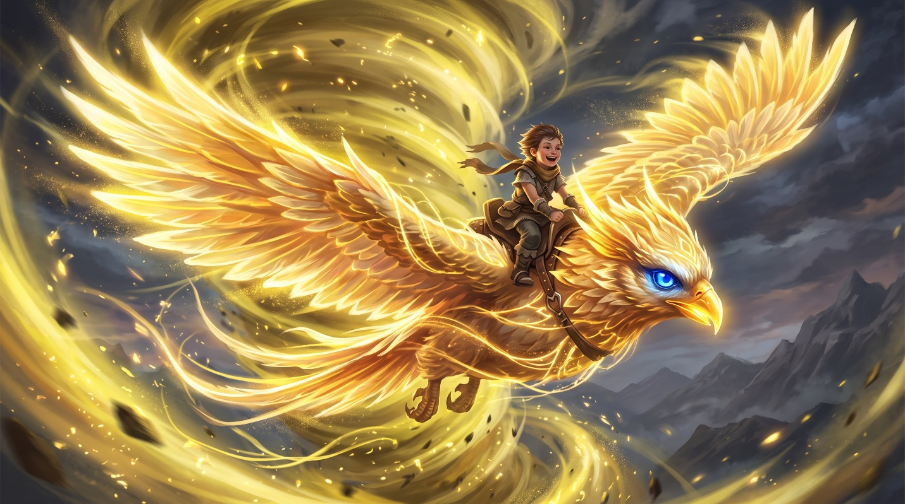
Spirition is a large spirit bird, it glows a yellow light and create yellow wind tornadoes by flapping its wings and using its will and intent. He can fly fast as the speed of sound. He can also see up to fifty miles ahead and avoid danger. He has a screech that freezes enemies stiff for long periods of time.
Entry # 0002 – Bonded Ori: (Olivia Cutes or Oliviania Cutes)
Next Spiroguard we will introduce is: Trickimon
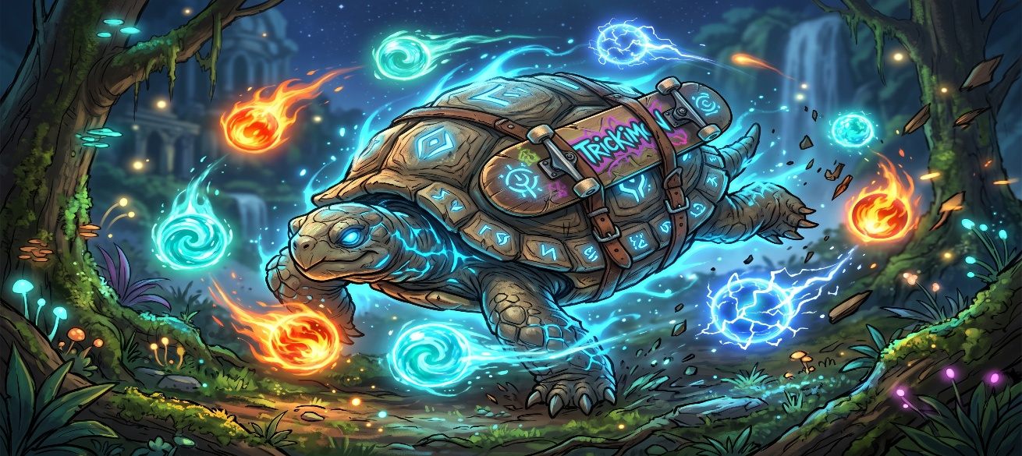.
Trickimon is a spirit turtle Spiroguard. His weapons are the magical balls that are constantly circling him as part of his aura. He is master of fire, water, and electricity. He is also an excellent skateboarder and can kick flip with the best of them. He is fearless and will try anything.
Entry # 0003 – Bonded Ori: (Evan Cutes or Evijino Cutes)
Next Spiroguard we will introduce is: Slithermon. A spirit snake.
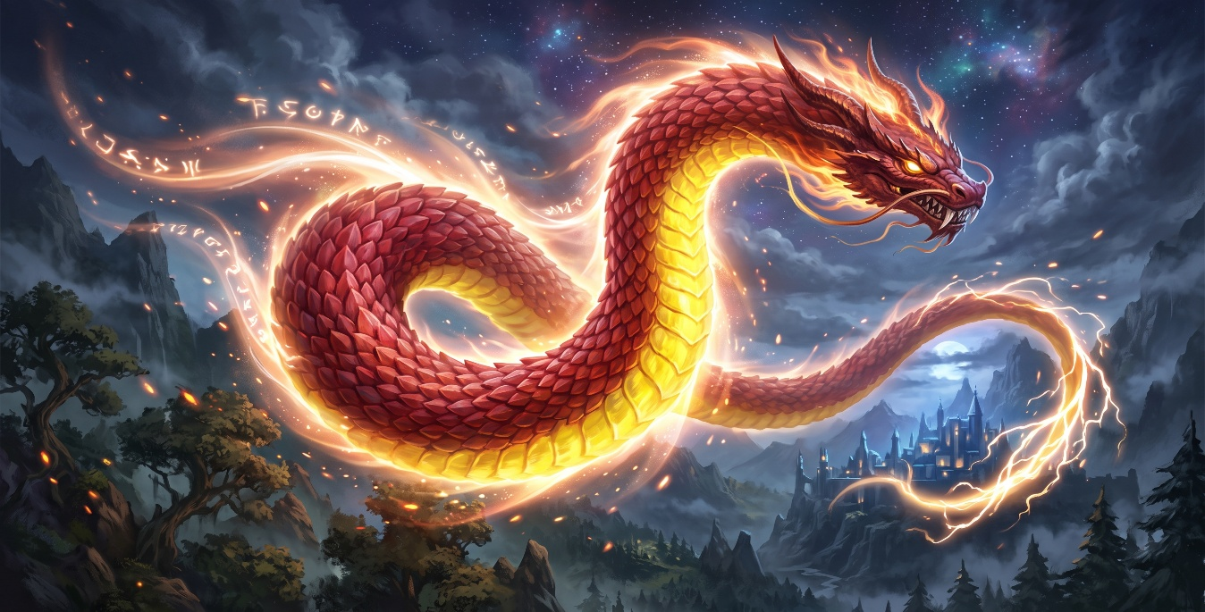
Slithermon is a massive spirit snake. He can burrow his way to the center of the planet effortlessly. He can shoot spirit lasers out of his eyes that cut through anything no matter how resilient. He can also fly as fast as a 747 plane.
Entry # 0004 – Bonded Ori : (O-Davinji)

Next Spiroguard we will introduce is Digiflyer. A digital spirit bird Spiroguard.
SPIROGUARD ENTRY #0005 | DIGIFLYER
Class / Type: Digital Aerial Guardian / Cyber-Avian
Domain: The Higher Digital Frequencies (The Spirit Realms)
Element / Affinity: Digital Light & Long-Range Network Override
Bonded Ori: Windy
Visual & Physical Design
- Monochrome Cyber-Plumage: Designed in a striking balance of sleek white, black, and charcoal grey feathers intercut with glowing digital circuit lines.
- Digital Light Aura: Emits a crisp, bright digital light glow—illuminating the surrounding environment with floating wireframes, binary cascades, and glowing grid lines.
- Scale & Presence: A majestic, large-scale bird big enough to comfortably carry Windy on its back through both the physical atmosphere and the digital matrix.
Abilities & Tactical Role
- Overhead Network Override (Aerial Hacking): Just as Techimon hacks digital systems up close, Digiflyer casts a broad digital field beneath its wings. Simply by soaring above any digital tech, defense grid, or network hub, Digiflyer can instantly hijack, override, or shut down systems from the sky.
- Matrix Sight: Sees the physical world as a 3D digital wireframe overlay, pinpointing vulnerabilities, electrical currents, and data streams instantly.
- Digital Light Flash: Can flare its white and grey wings to emit a high-frequency flash of pure digital light, blinding enemies and disrupting enemy electronic/magical sensors.
Encyclopedia Entry Draft
Digiflyer is an aerial digital Spiroguard that serves as the sky guardian for Windy. Clad in a sleek, monochrome plumage of white, black, and dark grey, Digiflyer radiates a radiant digital light. Large and powerful enough to carry a rider across vast distances, Digiflyer shares Techimon’s digital matrix perception—viewing the world as glowing streams of data and code.
Unlike ground-based guardians, Digiflyer’s hacking capability operates from above: by flying directly over any digital structure, mainframe, or defense grid, it can project a digital override wave that disables or controls the technology below.

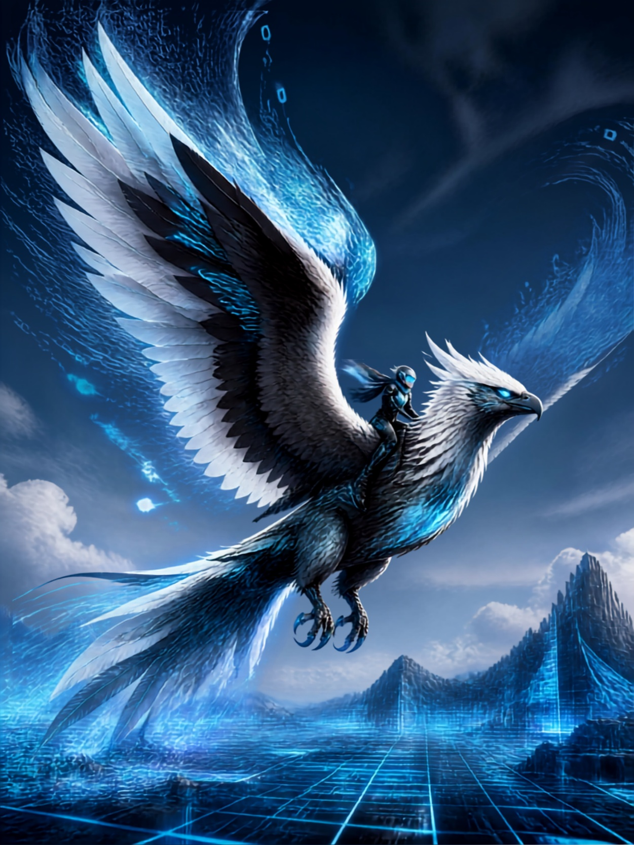
Depiction of Digiflyer with Windy riding on her back.

Next Spiroguard we will introduce is Beromon. A Spirit Bear Spiroguard.
SPIROGUARD ENTRY #0006 | BEROMON
Class / Type: Armored Beast Guardian / Spirit Bear
Domain: The Golden Peak (The Spirit Realms)
Element / Affinity: Radiant Golden Aura & Heavy Fortification
Bonded Ori-Mon: Orijinis (Master Swordsman)
Visual & Physical Design
- Golden Spirit Form: A massive, powerful bear with gleaming golden fur that radiates a warm, luminous aura.
- Glow & Eyes: Piercing, brilliant blue eyes that shine through his metal faceplate.
- Armored Defense: Clad in a heavy suit of carved metallic spirit armor with a fitted battle saddle on his back.
- Rider (Orijinis): Master swordsman Orijinis, dressed in spotless white robes, wielding his white-glowing omuragi (magical katana).
Abilities & Battle Synergy
- Unstoppable Charge: Beromon can channel his golden aura directly into his heavy metal armor, turning himself into an impenetrable battering ram that shatters enemy lines and defense barriers.
- Blade & Paw Coordination: While Beromon strikes with massive claw sweeps, Orijinis uses the height advantage from the saddle to unleash swift, precision strikes with his glowing white omuragi.
- Radiant Roar: Beromon releases a sonic golden wave that blinds foes and emboldens nearby allies.


